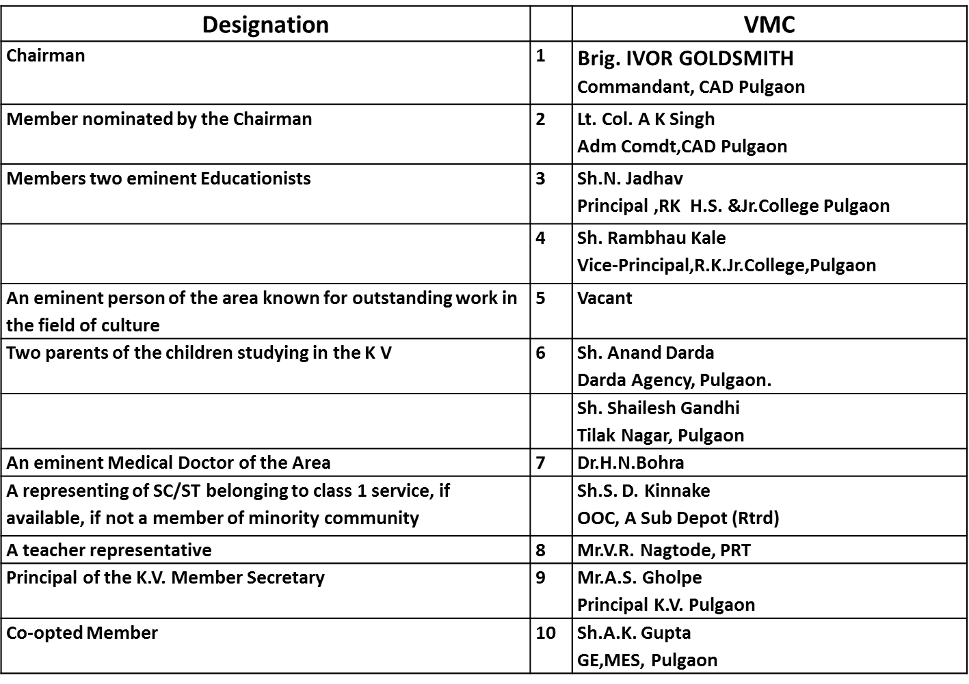

**KENDRIYA VIDYALAYA PULGAON CAMP (MS)**

**VIDYALAYA MANAGEMENT COMMITTEE**